B. K. N. Govt. Polytechnic, Narnaul
Faculty Profile: Computer Engg. Department

Sr. No. | Name of Faculty with Designation & Photo |  | Qualification
1. | Sh. Anil Parkash  Lecturer | 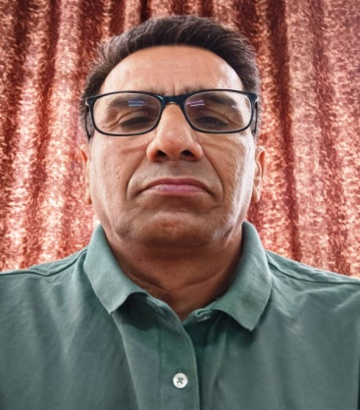 | B. E. , L.L.B
2. | Sh. Abhey Singh  Lecturer | 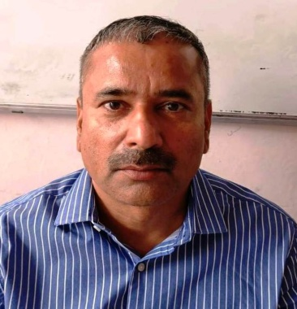 | M. C. A.
3. | Smt. Monika Rohilla  Lecturer | 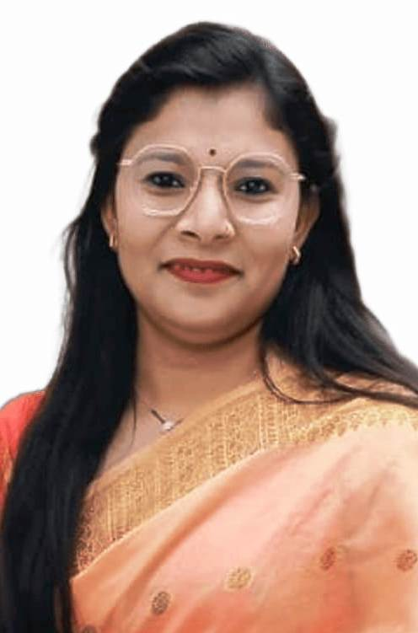 | M. Tech.
4. | Sh. Vinay Kumar  Programmer | 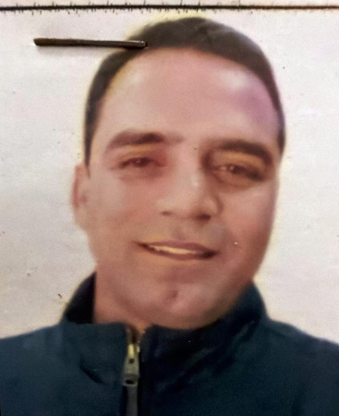 | M. C. A.

